**MICROSOFT POWER AUTOMATE DOCUMENTATION**

Overview 2

Types of Flows 2

Cloud flows 2

Desktop flows 2

Business process flows 2

Sign up 3

Sign up and sign in for Power Automate 3

Sign up free 3

Sign in 3

Use paid features 3

Troubleshooting 3

Next steps 4

Get Started with Power Automate 4

1 – Left navigation pane 5

Pin and unpin 7

Discover all 7

Move up or move down 8

Power Platform 8

2 – Search 9

3 – Environment information and settings 9

Choose an environment 9

Settings 11

Help 12

4 - AI Copilot 13

5 – Learning tools and more 13

6 - Ask a chatbot 14

Create and manage flows in Power Apps 14

Cloud Flows 14

Desktop Flows 14

# Overview

## Types of Flows

Power Automate is a service that you can use to automate repetitive tasks to bring efficiency to any organization.

You can create cloud flows, desktop flows, or business process flows.

### Cloud flows

Create a cloud flow when you want your automation to be triggered either automatically, instantly, or via a schedule.

### Desktop flows

Use [desktop flows](https://learn.microsoft.com/en-us/power-automate/desktop-flows/introduction) to automate tasks on the Web or the desktop.

### Business process flows

[Business process flows](https://learn.microsoft.com/en-us/power-automate/business-process-flows-overview) provide a guide for people to get work done. They provide a streamlined user experience that leads people through the processes their organization has defined for interactions that need to be advanced to a conclusion of some kind. This user experience can be tailored so that people with different security roles can have an experience that best suits the work they do.

## Sign up

## Sign up and sign in for Power Automate

Starting with Power Automate, as an individual, is easy! Before you can create a cloud flow, sign up by using any email address. If you've never used an online Microsoft product with that address, you'll need to take a few moments to register it.

### Sign up free

If you haven't used other online Microsoft products, you'll need to sign up.

1. In [Power Automate](https://make.powerautomate.com/), select **Try free** in the upper-right corner.
2. Enter your email address.
3. Select the right arrow.

### Sign in

If you've used other Microsoft online products, either for work or yourself, all you need to do is sign in.

### Use paid features

Anyone can sign up and get a free plan for Power Automate. If your organization has purchased Microsoft 365 or Dynamics 365, you may already have access to Power Automate. You can also start a 90 day free trial, or purchase a Power Automate license if you want to use the paid features.

For administration information, go to [Flows in your organization Q&A](https://learn.microsoft.com/en-us/power-automate/organization-q-and-a).

### Troubleshooting

In many cases, you can register for Power Automate by following the simple process described previously in this topic. However, this table summarizes the most common reasons why you might not be able to sign up, and describes available workarounds.

Next steps

* [Start with a template](https://learn.microsoft.com/en-us/power-automate/get-started-logic-template), which is a prebuilt flow that's set up for you.
* [Start from blank](https://learn.microsoft.com/en-us/power-automate/get-started-logic-flow), if you already have a process in mind and can't find a template for it.
* Get help planning your [cloud flow project](https://learn.microsoft.com/en-us/power-automate/guidance/planning/introduction).

## Get Started with Power Automate

The Power Automate home page offers you various options for creating your own flows and learning about the key features for Power Automate. You can get a quick sense of what's possible and how Power Automate can help your business.

If your organization has AI enabled, then it also includes the new Copilot features.

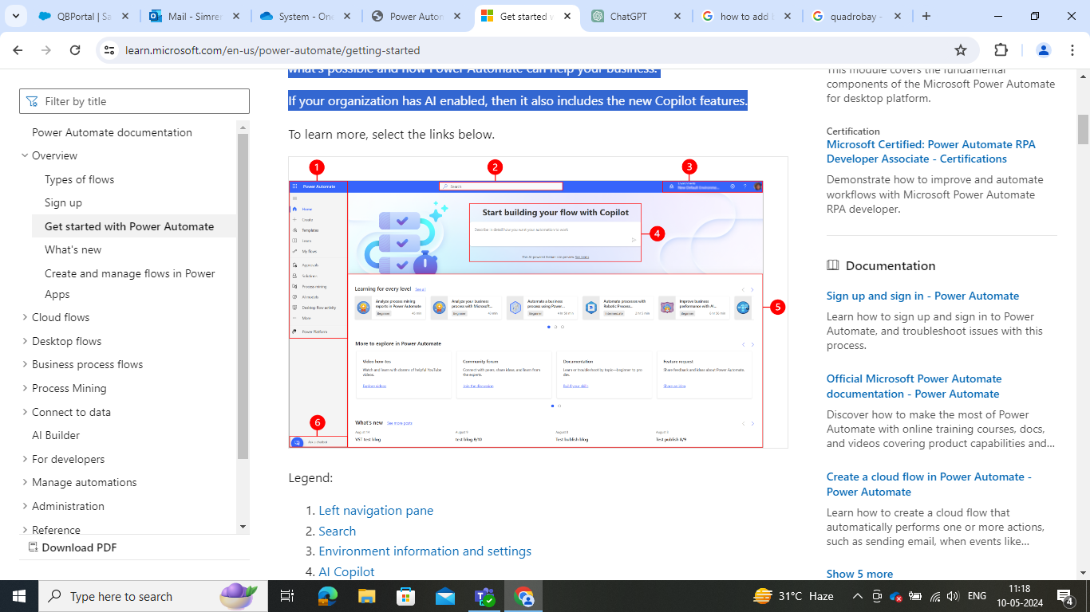

Legend:

1. Left navigation pane
2. Search
3. Environment information and settings
4. AI Copilot
5. Learning tools and more
6. Ask a chatbot

### 1 – Left navigation pane

Find what you need with the left navigation pane. When you sign in to [Power Automate home page](https://make.powerautomate.com/), the left navigation pane shows the following menu items:

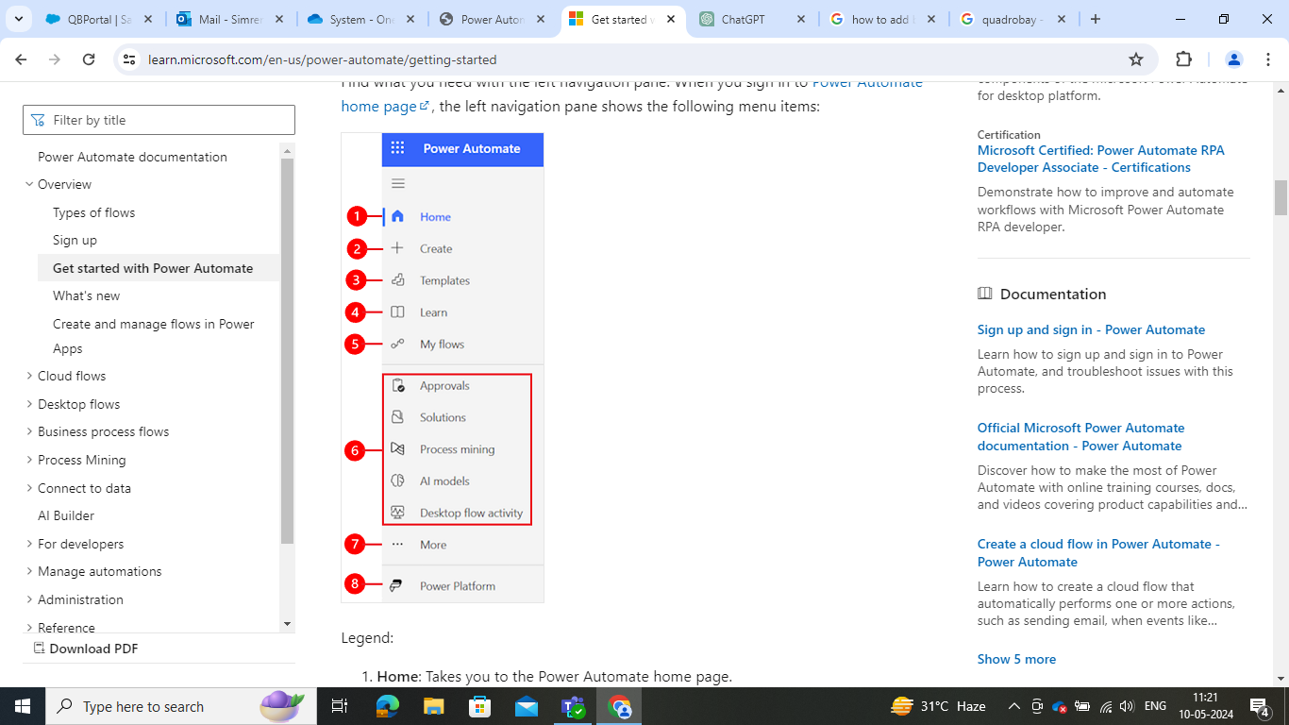

Legend:

1. **Home**: Takes you to the Power Automate home page.
2. **Create**: Create flows by using Copilot, templates or build your own.
3. **Templates**: View and search for templates you can use to create flows.
4. **Learn**: Learn experience takes you to the Power Automate product documentation.
5. **My Flows**: If you've created a flow, or someone else has created one and shared it with you, you can view or edit it.
6. **Your most used pages**: When you first sign in, items such as **Approvals**, **Solutions**, **Process mining**, **AI models**, and **Desktop Flow Activity** appear in the left navigation menu by default. Use the **More** menu item to [unpin](https://learn.microsoft.com/en-us/power-automate/getting-started#pin-and-unpin) any of these items and [pin](https://learn.microsoft.com/en-us/power-automate/getting-started#pin-and-unpin) something else.
7. **More**: [Pin](https://learn.microsoft.com/en-us/power-automate/getting-started#pin-and-unpin) your most used items to the left navigation pane, such as **Tables**, **Cloud flow activity**, **Connections**, and more.
8. **Power Platform**: Explore other Power Platform products.

#### Pin and unpin

Pin your most used pages in the navigation pane so you can quickly access features that you use frequently. Links to other pages are available through the **More** menu item. When you pin an item, it appears in the middle section above **More**.

When you sign in, the left navigation pane contains **Templates**, **Approvals**, **Solutions**, **Process mining**, **AI models**, and **Desktop Flow Activity**. However, you can pin and unpin pages to customize it to your preference.

To pin or unpin an item from the left navigation pane, select **More**, and then select the Screenshot of the Pin icon. pin button or Screenshot of the Unpin icon. unpin button.

You can also unpin an item by selecting the vertical ellipsis (**⋮**) next to the item > **Unpin**.

#### Discover all

Select **Discover all** to see the **Discover** page on the left navigation pane.

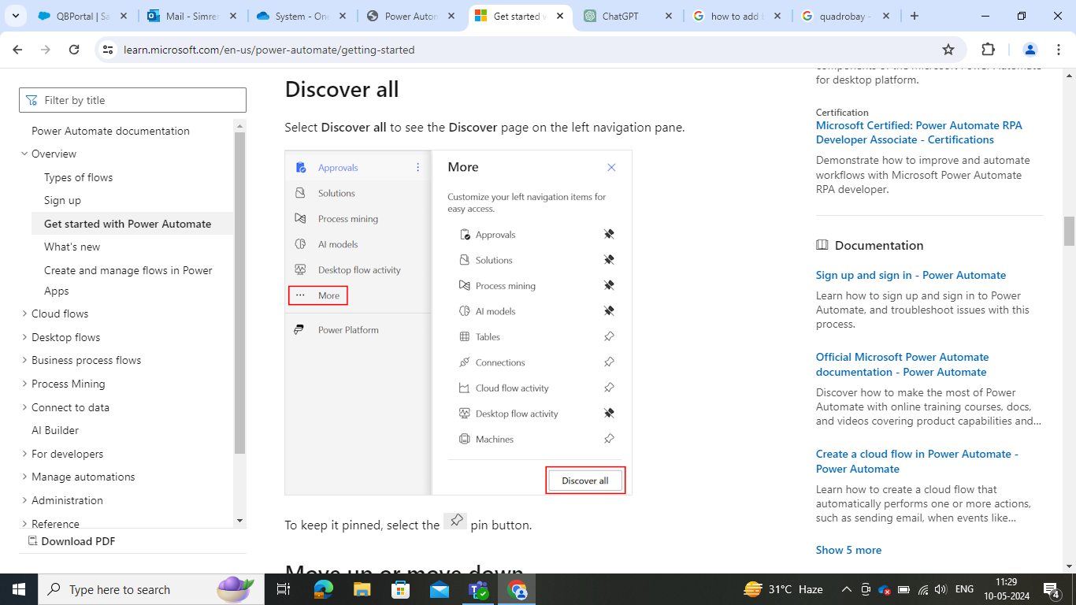

To keep it pinned, select the Screenshot of the Pin icon. pin button.

#### Move up or move down

When you have some pages pinned in the navigation pane, you can move them up or down.

To move a page up or down, select the vertical ellipsis (**⋮**) next to the menu item that you want to move, and then select **Move up** or **move down**.

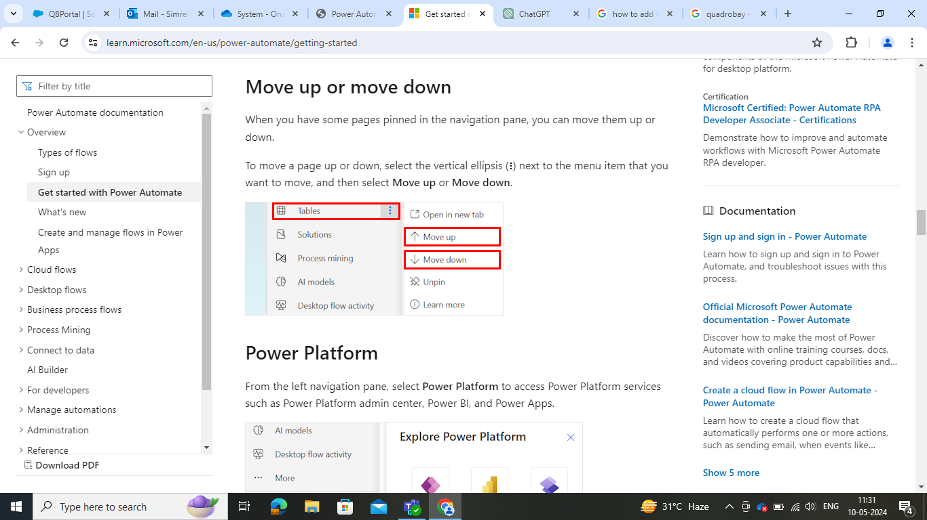

#### Power Platform

From the left navigation pane, select **Power Platform** to access Power Platform services such as Power Platform admin center, Power BI, and Power Apps.

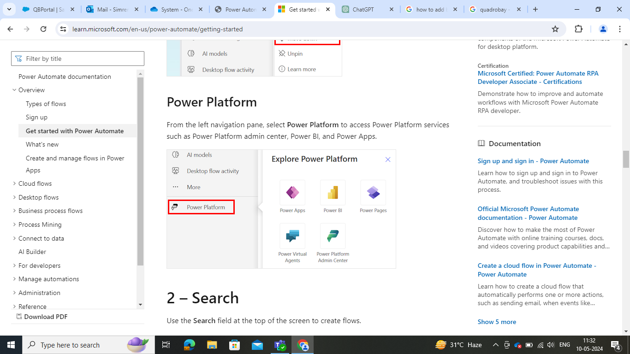

### 2 – Search

Use the **Search** field at the top of the screen to create flows.

### 3 – Environment information and settings

View your environment information and settings.

#### Choose an environment

Environments create boundaries between different types of work. For example, an organization might have separate environments for different departments. Many organizations use environments to separate flows that are still being developed from those that are ready for widespread use. You might have access to multiple environments or only one. If you have the appropriate permissions, you might even be able to create your own environments.

To verify which environment you're in, find the environment switcher near the right side of the header.

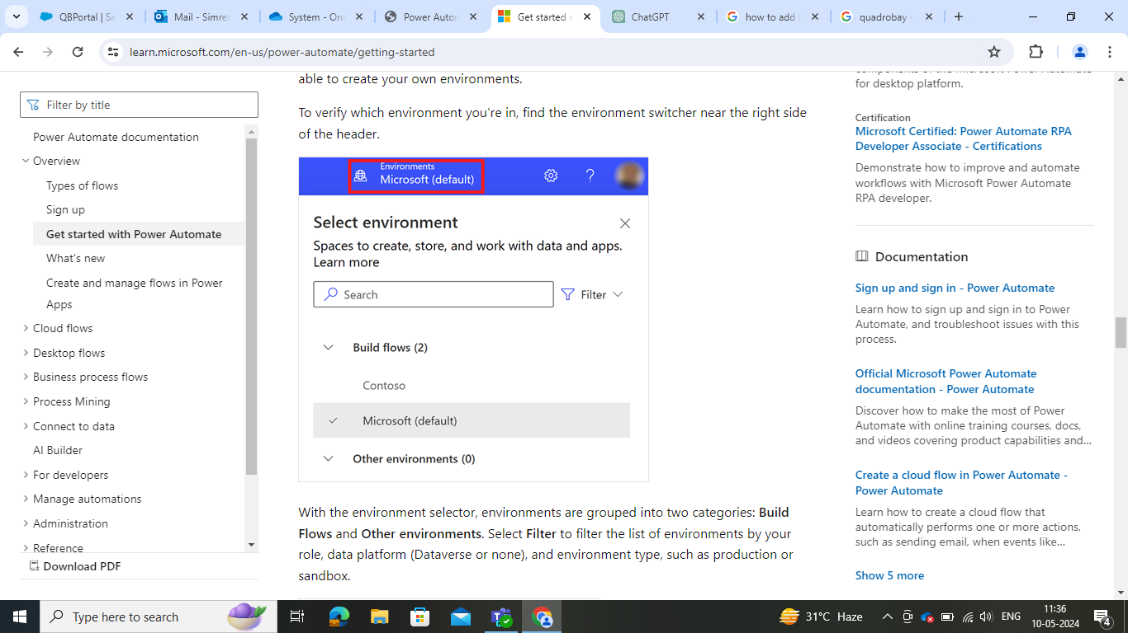

With the environment selector, environments are grouped into two categories: **Build Flows** and **Other environments**. Select **Filter** to filter the list of environments by your role, data platform (Dataverse or none), and environment type, such as production or sandbox.

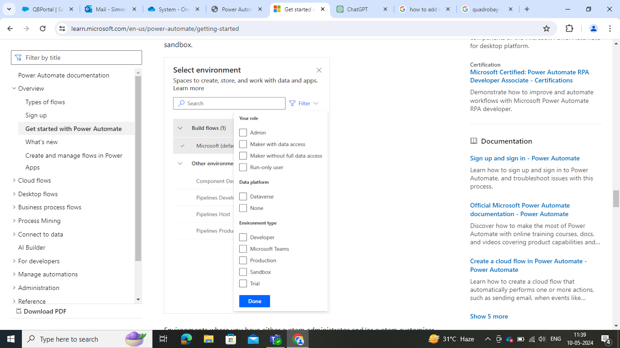

Environments where you have either system administrator and/or system customizer security role membership appear under **Build flows.** The **Other environments** list displays environments where you have read-only permissions, and can access approvals.

**Filter environments by role**

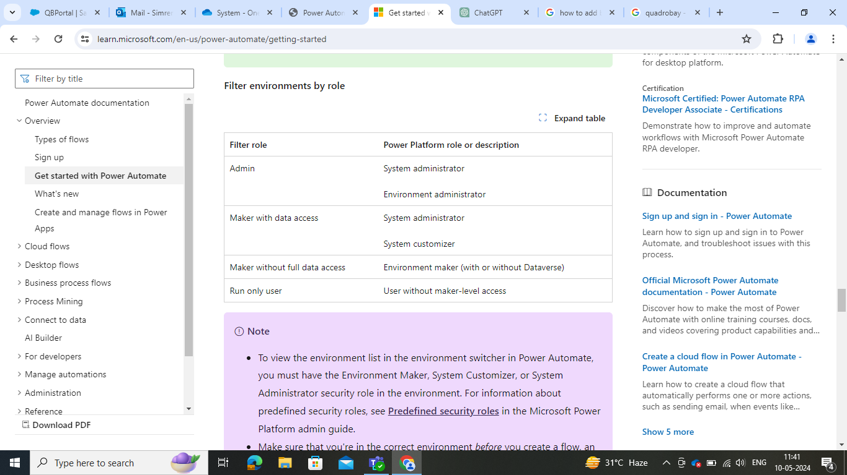

#### Settings

Select the gear icon to perform tasks such as identify your Power Automate licenses, and open the page where you can perform administrative tasks.

* **Admin Center**: Opens the Power Platform admin center.
* **View all Power Automate Settings**: View or update your language and time settings, notifications, or access directories.
* **View My Licenses**: View your licenses. To learn more, go to [Licensing overview for Microsoft Power Platform](https://learn.microsoft.com/en-us/power-platform/admin/pricing-billing-skus).
* **Themes**: From the list of themes, select a theme for your organization.
* **Password**: Change your password.
* **Contact preferences**: Update your contact information.

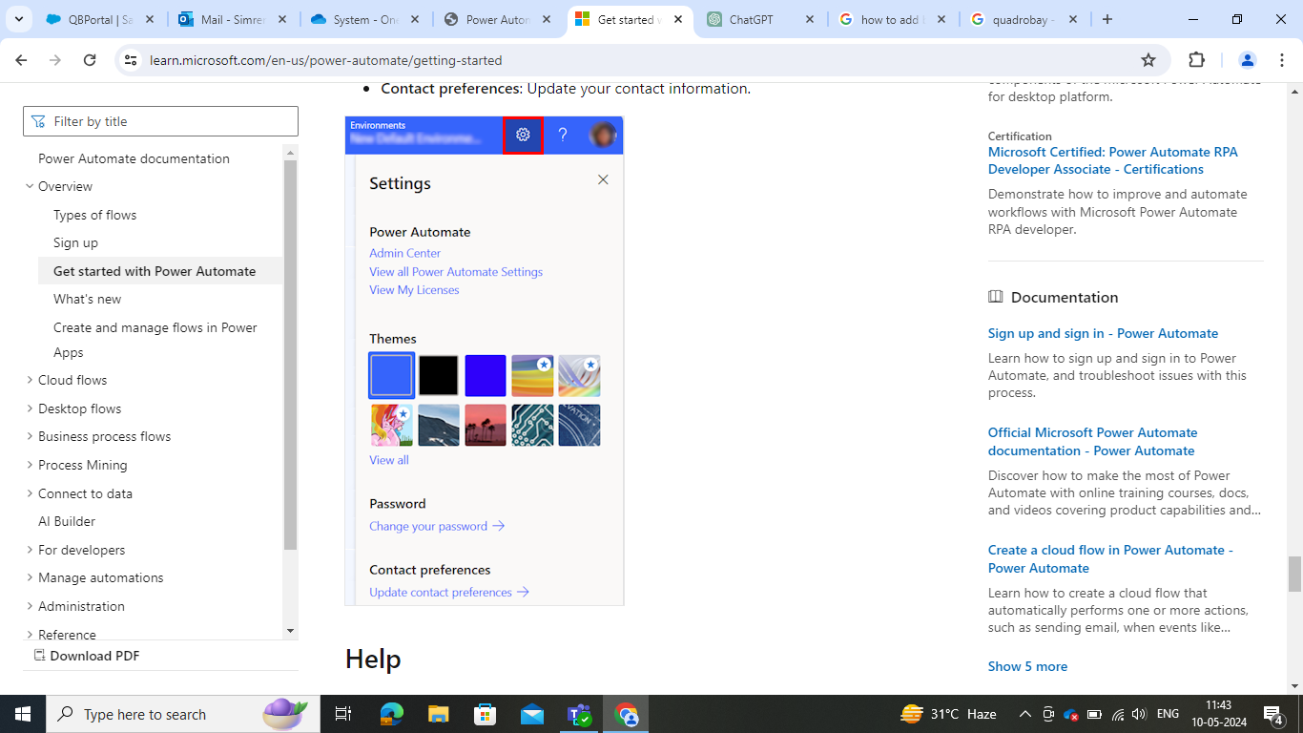

#### Help

In the header, select the question mark icon to find more information about Power Automate.

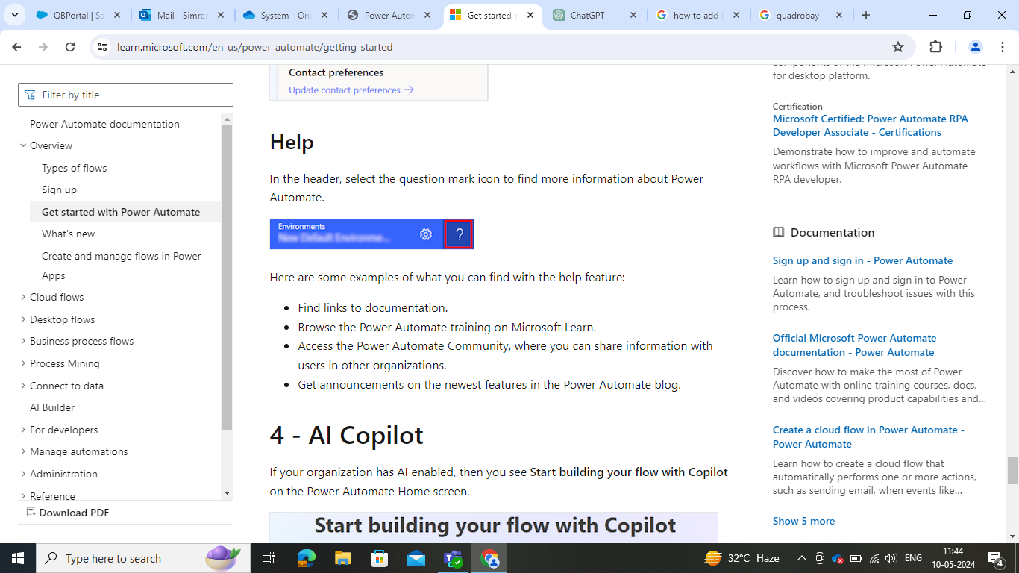

Here are some examples of what you can find with the help feature:

* Find links to documentation.
* Browse the Power Automate training on Microsoft Learn.
* Access the Power Automate Community, where you can share information with users in other organizations.
* Get announcements on the newest features in the Power Automate blog.

### 4 - AI Copilot

If your organization has AI enabled, then you see **Start building your flow with Copilot** on the Power Automate Home screen.

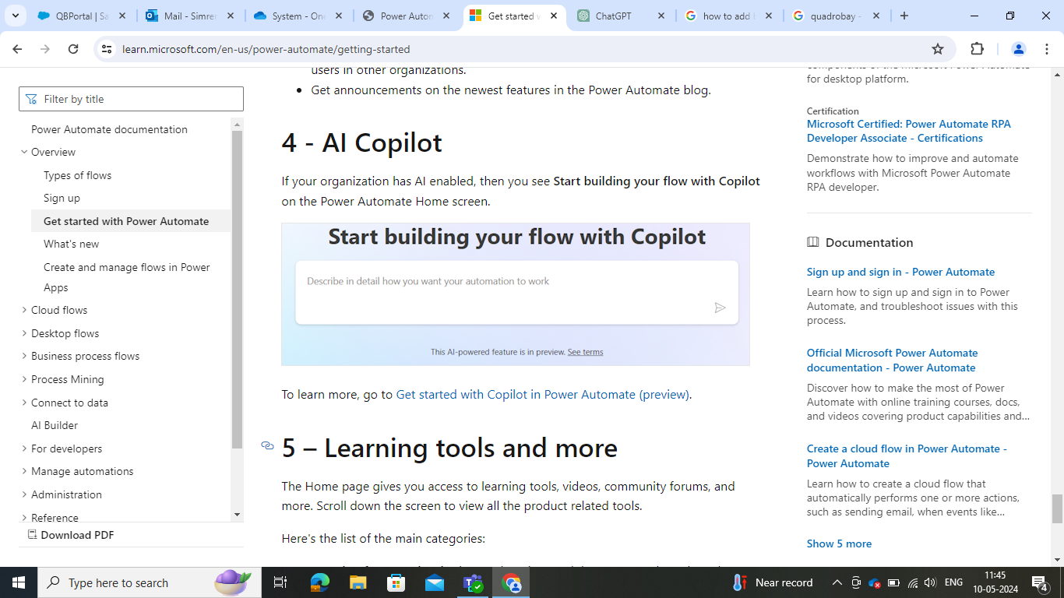

### 5 – Learning tools and more

The Home page gives you access to learning tools, videos, community forums, and more. Scroll down the screen to view all the product related tools.

Here's the list of the main categories:

* **Learning for every level:** Discover learning modules you can take to learn how to use Power Automate.
* **More to explore in Power Automate:** Discover all that Power Automate has to offer such as video how-tos and the Power Automate Community forum.
* **What's new:** Learn about upcoming events as well as new and updated product features.

### 6 - Ask a chatbot

Get contextual help while building your flow using the Power Platform virtual agent. To learn more, go to [Get contextual help with flows from the Microsoft Copilot Studio bot](https://learn.microsoft.com/en-us/power-automate/contextual-help-bot).

## Create and manage flows in Power Apps

Your Power Automate license also gives you rights to create and manage flows in Power Apps. Here are the ways you can do this in Power Apps.

* Through Power Apps. After you sign in to Power Apps, select **Flows** in the left navigation pane.
* Through Power Automate pane within Power Apps Studio.

Check out the Power Automate Get started guide to create your first flow.

# Cloud Flows

# Desktop Flows